RESIDENTIAL REAL ESTATE PHOTOGRAPHY

STANDARD HDR PHOTOGRAPHY:

For standard MLS listings using HDR (High Dynamic Range) photography with 24-hour turnaround

BASIC: 24 PHOTOS - recommended for townhomes & condos, & homes under 1500 sf ………….... $175

STANDARD: 36 PHOTOS - recommended for homes 1500-3000 sf ……..…….…..….……..….…... $225

PREMIUM: 48 PHOTOS - recommended for homes 3000-5000 sf ………..….…….…….……..….... $280
Includes Marketing Kit & Basic Floor Plan

LUXURY: 60+ PHOTOS - recommended for large properties over 5000 sf, starting at ….…....…….... $360
Includes Marketing Kit & Fixed Furniture Floor Plan

HIGH END PHOTOGRAPHY:

Recommended for premium listings & luxury properties, custom home builders, vacation rentals and architectural/interior design projects.
Incorporates the use of flash lighting equipment, if needed, custom editing techniques and hand-blended images for higher quality photos with 24–36 hour turnaround

STANDARD PLUS: 40+ PHOTOS - recommended for homes 2000-3500 sf ….……….…....……… $400
Includes One Virtual Twilight Photo

PREMIUM PLUS: 50+ PHOTOS - recommended for homes 3500-5000 sf …...……...…........……… $475
Includes Basic Floor Plan & Two Virtual Twilight Photos

LUXURY PLUS: 60+ PHOTOS – recommended for large properties over 5000 sf, starting at ……... $550
Includes Fixed Furniture Floor Plan & Two Real-Time Twilight Photos

All High-End Photography includes sky replacement, digital fire in fireplace, picture in tv screen, clear window views, closeup vignettes & complete marketing kit (website, flyers, social media tiles & teaser video).

PHOTOGRAPHY ADD ONS:

MARKETING KIT (property website, social media templates, printable flyers, teaser video…) ........…. $20
TWILIGHT (real time) …………………………………………………...…….…….…… 4 photos for $170
SIMULATED TWILIGHT (day to dusk) …………….…... per image …….............…………………… $35
VIRTUAL FURNITURE STAGING ……………………. per image …………….....….….…....……... $50
DIGITAL FIRE IN FIREPLACE ………………………… per image ………….….….…….….…....…. $10
GRASS GREENING …………………………………….… per image ……….…….…….…....….….…. $20
DIGITAL WINTER TO SUMMER CONVERSION …… per image ……… quoted on an individual basis
CLUTTER REMOVAL …………………………………………………...…... quoted on an individual basis
COMMUNITY AMENITIES COLLECTION (4-8 photos of nearby neighborhood amenities) ...…..…. $30
DIGITAL PICTURE IN TV and SKY REPLACEMENTS ……. now included at no additional charge
DRONE / VIDEO / 3D VIRTUAL TOURS

DRONE AERIAL PHOTOGRAPHY:

AERIAL PHOTOS (4-6 photos) ………………………...……………………..………...…………….… $125
AERIAL PHOTOS & VIDEO PACKAGE ……………………...…………….…………..…………….. $225
(Package includes up to 6 photo images & up to 30 seconds of video)

DRONE AERIAL VIDEO:

STANDARD AERIAL VIDEO (30 sec.) .………………………………………..….…….…………...… $130
EXTENDED AERIAL VIDEO (60 sec.) for larger properties with multiple acres ….…………………… $185

VIDEO:

STANDARD VIDEO (up to 60 sec.) …...….……………………….…….…...……....……….……….… $250
EXTENDED VIDEO (up to 120 sec.) includes aerial video …………......………...……….…….….....…. $350
VIDEO REEL for social media (30-60 sec.) with music or add your own ……………...…………………. $125

VIRTUAL TOURS: priced per square foot

3D VIRTUAL TOUR with Standard* Floor Plan …………... CALL FOR QUOTE ….…starting at $250 3D VIRTUAL TOURS with Premium** Floor Plan ………... CALL FOR QUOTE ….... starting at $300

Virtual Tour Premium* Floor Plan includes Fixtures & Appliances

STANDARD* PREMIUM**
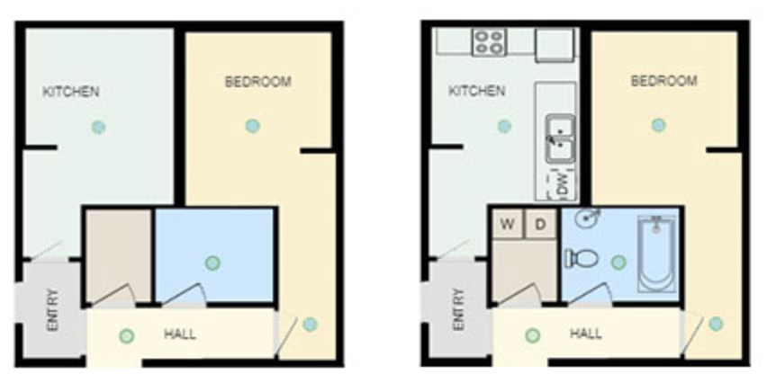

FLOOR PLANS
ordered without a virtual tour

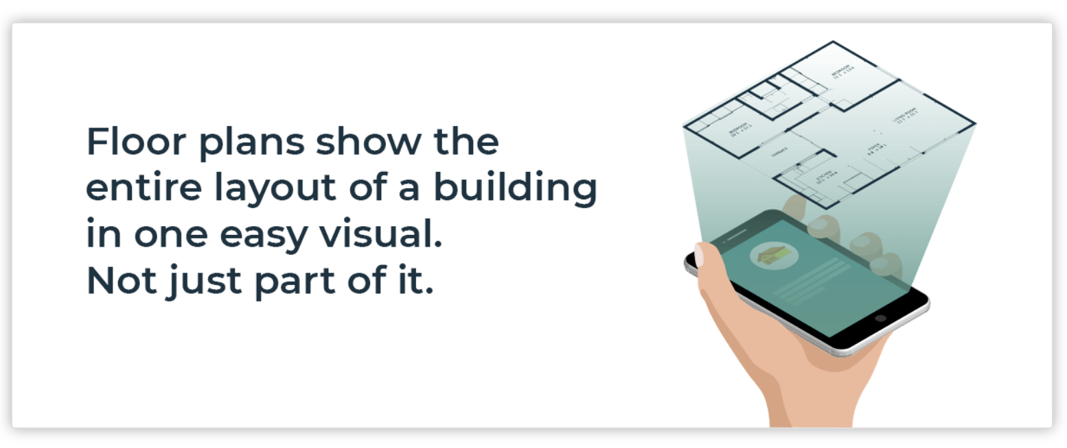

Floor Plans are the second most important feature on a listing, according to home buyers (NAR report). Use them for APPRAISALS, as well as REAL ESTATE LISTINGS.

When ordered without a virtual tour:

Basic Floor Plan* ……………………………...………………………………………………...….….... $ 40
Premium Floor Plan** (includes appliances, cabinets, counters, doors, tubs, showers, toilets, etc) ………….… $ 65
GLA Floor Plan (for Appraisal Reports) …………….……………………………….……….………... $ 50
RUSH - Same Day Turnaround ……………………………………………………………………….…. $ 10
All Floor Plans are for Homes up to 4000 sf For Homes OVER 4000 sf add $20

BASIC FLOOR PLAN* PREMIUM FLOOR PLAN**
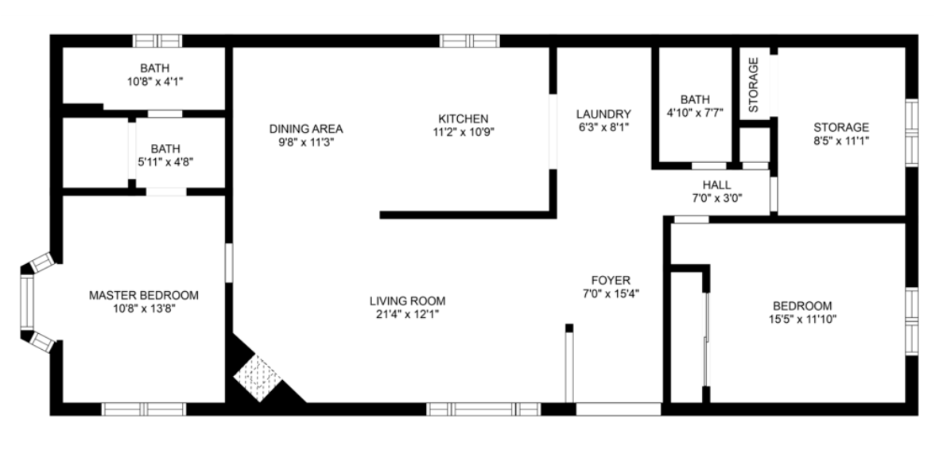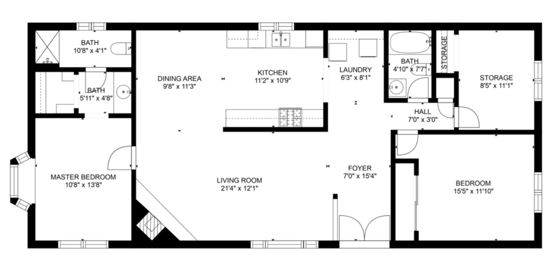

FLOOR PLANS come with or without ROOM MEASUREMENTS
*Comes with your choice of layouts, colors, shading, etc. at no extra charge (see below)

COMBO PACKAGES

A) AERIAL / PHOTO PACKAGE: (valued at $475, save $85) …………………………………. $390

includes
35-45 PHOTOS - recommended for homes 1500-3500 sf
4-6 AERIAL PHOTOS
1 VIRTUAL TWILIGHT
1 FLOOR PLAN
1 MARKETING KIT

B) VIDEO / PHOTO PACKAGE: (valued at $600, save $100) …………….………….…...…… $500

includes
35-45 PHOTOS - recommended for homes 1500-3500 sf
60 SECOND VIDEO
1 VIRTUAL TWILIGHT
1 FLOOR PLAN
1 MARKETING KIT

C) 3D TOUR / PHOTO PACKAGE: (valued at $835, save $140) ……………………..….…… $695

includes
45-55 PHOTOS - recommended for homes 3000-5000 sf
4-6 AERIAL PHOTOS
3D TOUR, w/PREMIUM FLOOR PLAN
2 VIRTUAL TWILIGHTS
1 MARKETING KIT

ADD-ONs TO COMBO PACKAGES:

30 SECOND AERIAL VIDEO ……………………………………………….………………………… $95
60 SECOND INTERIOR VIDEO ………………………………………………………………….… $200
30 SECOND VIDEO REEL ……….…………………………………………………………………... $ 90
3D TOUR ………………………………………………….………... $50 OFF A-LA-CARTE PRICES

TRAVEL FEES

We are based in Camden County, NJ, but will travel just about anywhere to photograph your property.
Standard Coverage area includes most of South Jersey, Philadelphia, and Wilmington.
Travel fees may apply to areas beyond this, including Cape May Co., Ocean Co., parts of Burlington Co., Bucks Co., Montgomery Co., parts of Delaware & Chester Cos., and beyond.
Call for exact cost for your listing if it’s beyond the South Jersey area.

HEADSHOT AND GROUP PHOTOGRAPHY

HEADSHOT PHOTOGRAPHY & BUSINESS PORTRAITS:
Professional Headshots are done at the location of your choice (park, office, listing property or your home) or choose from a list of our favorite places near you.

Headshot Photography is simply creating some quick head & shoulders photos for business cards, websites, or social media.
The session takes about 20 minutes. Included are a variety of head & shoulders poses with 10-20 unedited previews to choose from. Starting price includes the session fee ($150) and one retouched image ($75) in various crops, in both color and B&W, with 6-8 final photos.

Business Portraits is an excellent way to showcase both your professionalism and personality, creating a variety of different looks, from casual to business professional, that can be used for multiple purposes.
The session takes about 30-45 minutes. Included are a variety of angles, poses, and backgrounds, from head & shoulders to full length, vertical & horizontal, with 30-50 unedited previews to choose from.
Starting price includes the session fee ($200) and one retouched image ($75) in various crops, in both color and B&W, with 8-12 final photos.

Group Sessions take about 15-25 minutes for smaller groups and 20-40 minutes for larger groups.
Groups will get to choose from 2-4 different poses, with 10-20 unedited previews to choose from.
The finished retouched photo will be delivered in various crops (if possible), in both color and B&W.

INDIVIDUAL HEADSHOTS (includes session fee and one retouched photo) ………………….……..…… $225
INDIVIDUAL BUSINESS PORTRAITS (includes session fee and one retouched photo) ...…………..…… $275

GROUP PHOTO of your Team or Brokerage (includes session fee and one retouched photo)
- 2-3 people in the group ………………………………………………….………..….…. $250
- 4-5 people in the group ………………………………………………….…..……….…. $325
- 6 or more people in the group …………………………………..…………..… Call for quote

GROUP & INDIVIDUAL HEADSHOT PACKAGE
- Add Individual Headshots to any Group Photo – save $100 each.
- Each Individual Headshot Added to the Group Photo ……………………….………... $125

Each Additional Retouched Photo …………………………………………………………...…………… $75

Turnaround time for Headshot Photography is 1 day for Previews & 3-5 days for delivery of Retouched Photo(s).

